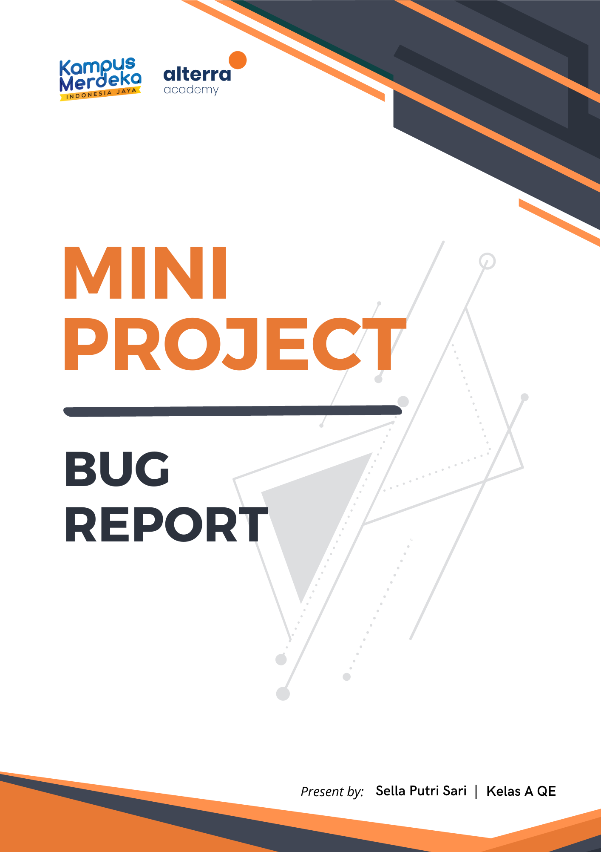

# **ALTA SHOP RESTAPI BUG**

1. **Authentication (Register)**

|  |  |
| --- | --- |
| Defect ID | API01 |
| Test ID | TCR_001 |
| Case | Send post http requests to register by filling invalid data on the body |
| Report Date | 10 Mei 2023 |
| Priority | High |
| Expected Result | Failed to register |
| Actual Result | Register success |
| Report To | Backend Developer |

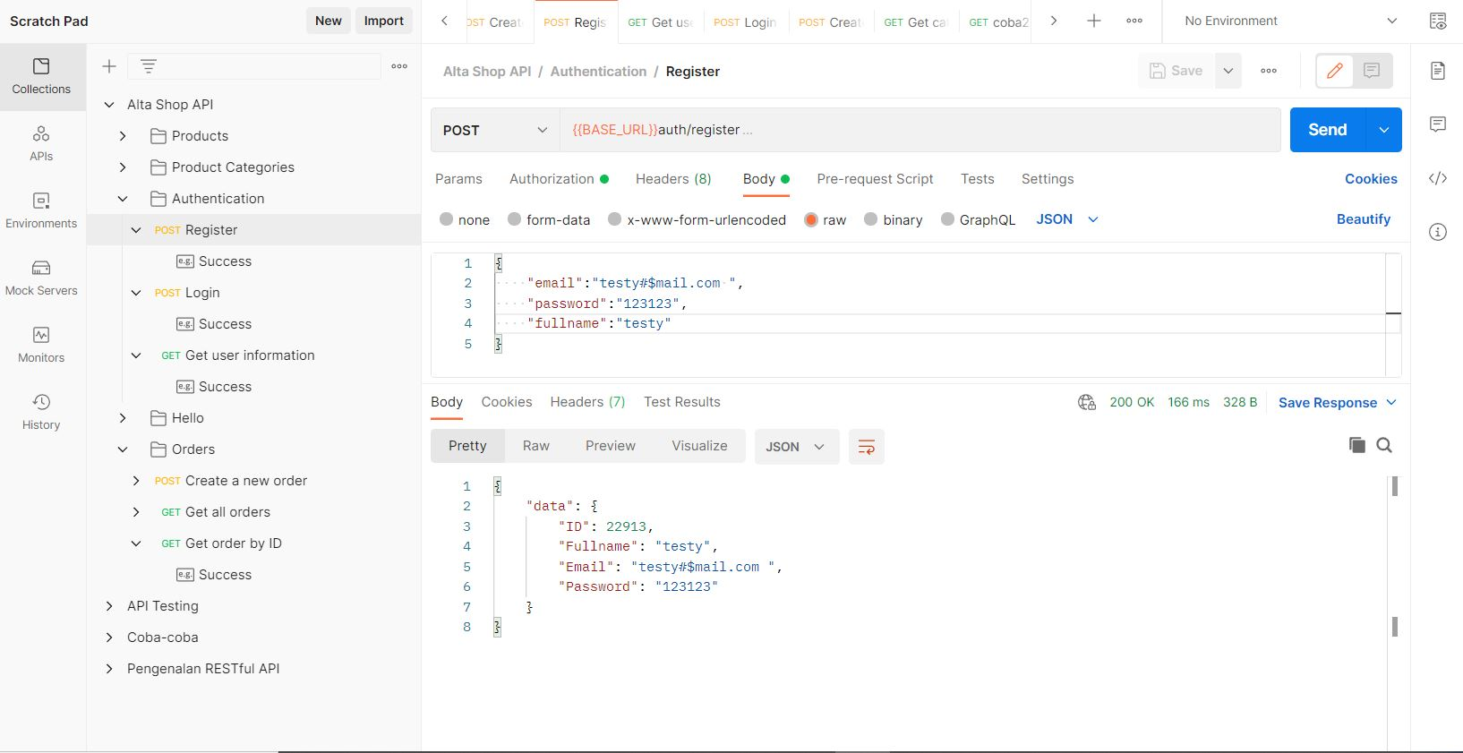

1. **Authentication Login**

|  |  |
| --- | --- |
| Defect ID | API02 |
| Test ID | TCR_002 |
| Case | Send post http requests to login by filling invalid data on the body |
| Report Date | 10 Mei 2023 |
| Priority | High |
| Expected Result | get error response status code and failed to login |
| Actual Result | get success response status code and success to login |
| Report To | Backend Developer |

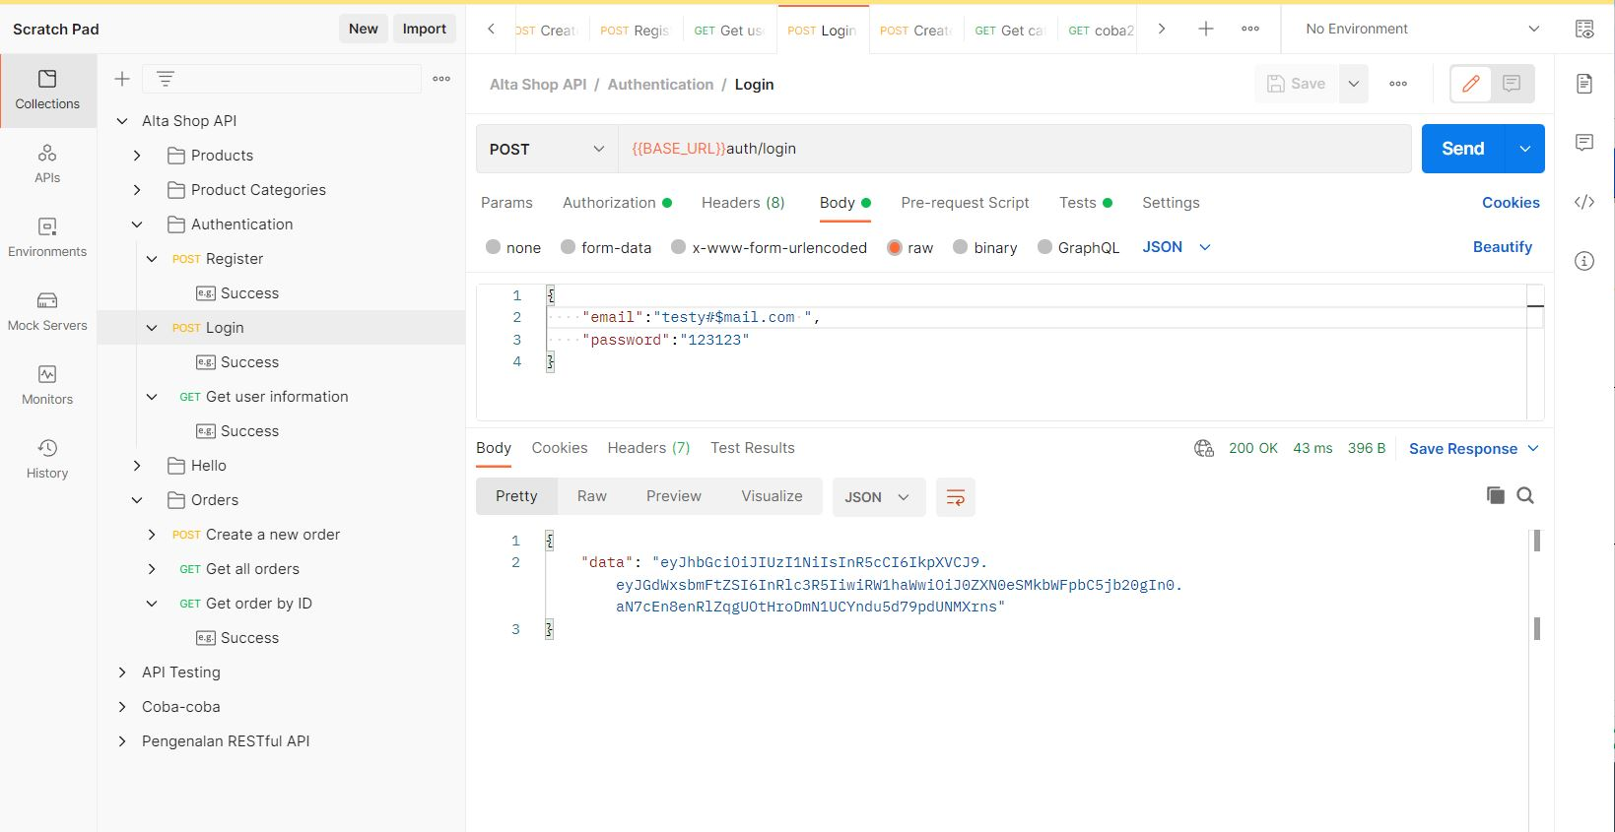

1. **Create New Order**

|  |  |
| --- | --- |
| Defect ID | API03 |
| Test ID | TCR_003 |
| Case | Send post http requests to register by filling invalid data on the body |
| Report Date | 10 Mei 2023 |
| Priority | High |
| Expected Result | Failed to register |
| Actual Result | Register success |
| Report To | Backend Developer |

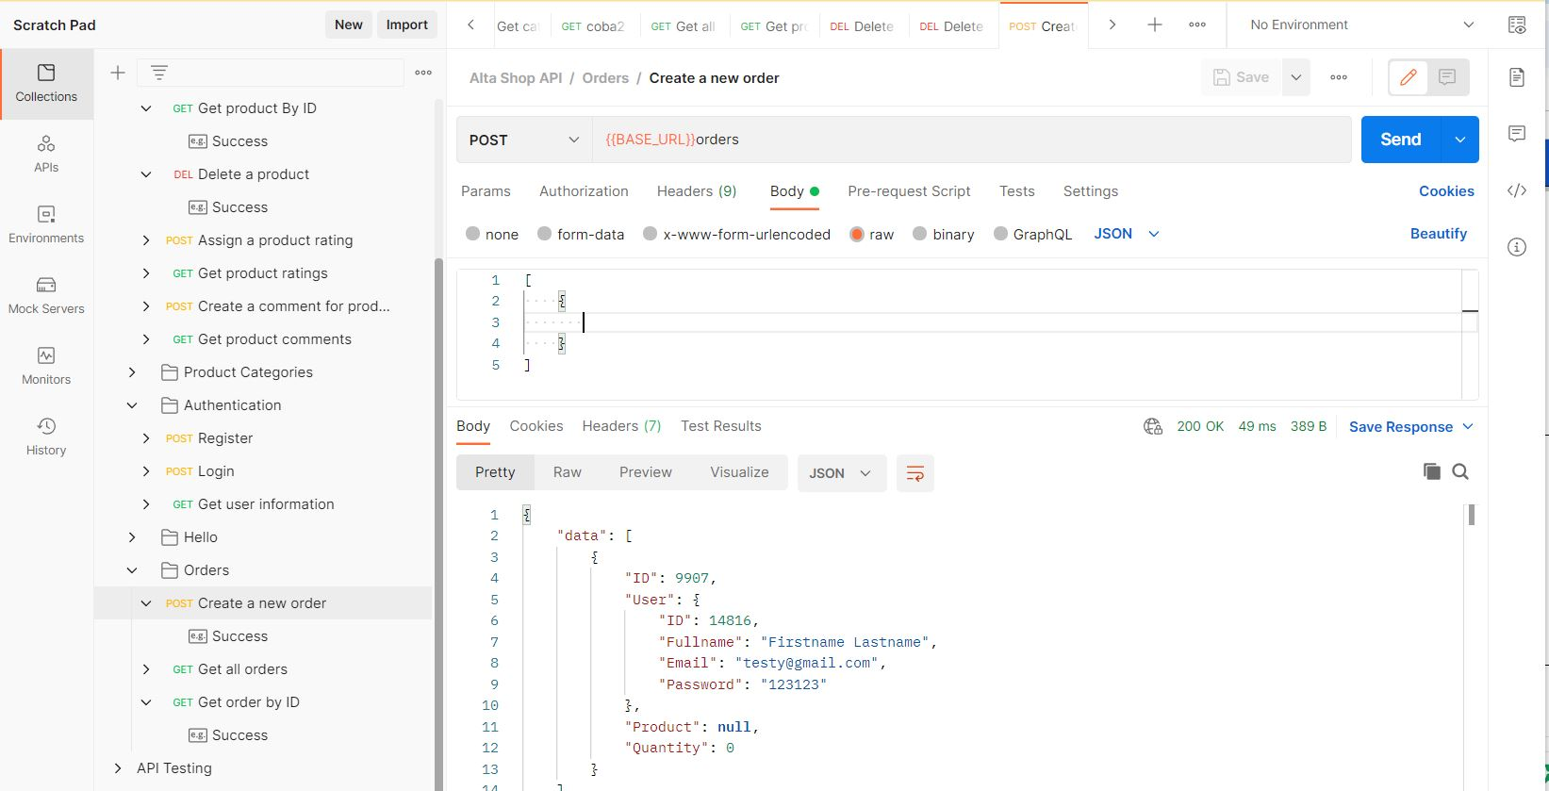

# **ALTA SHOP WEB UI BUG**

1. **Register User**

|  |  |
| --- | --- |
| Defect ID | WEBUI01 |
| Test ID | TCR_001 |
| Case | User register with invalid email credentials |
| Report Date | 10 Mei 2023 |
| Priority | High |
| Expected Result | Failed to register |
| Actual Result | Successfully to register user account |
| Report To | FrontEnd Developer |

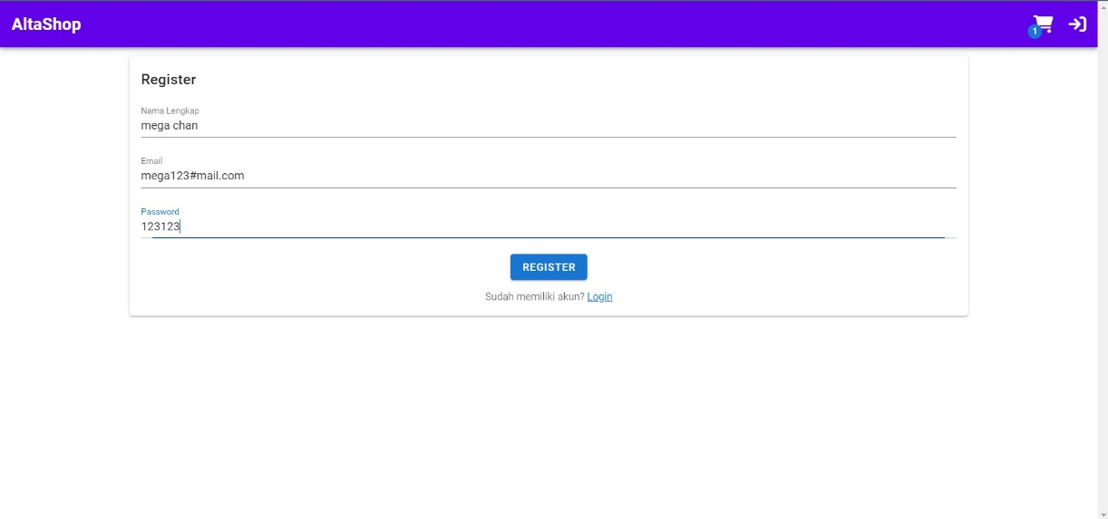

1. **Login User**

|  |  |
| --- | --- |
| Defect ID | WEBUI02 |
| Test ID | TCR_002 |
| Case | User login with input invalid email credentials of the field email |
| Report Date | 10 Mei 2023 |
| Priority | High |
| Expected Result | Show the error message and failed to login |
| Actual Result | No error message appears and successfully to login and direct to homepage |
| Report To | FrontEnd Developer |

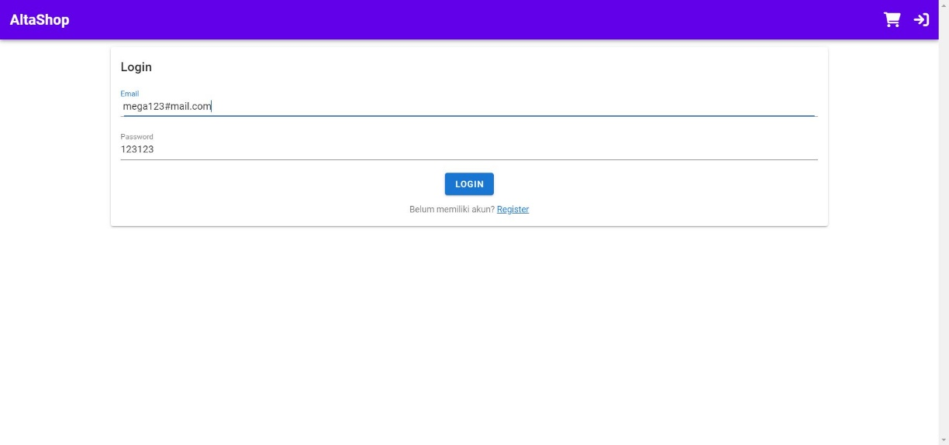

1. **Select Category**

|  |  |
| --- | --- |
| Defect ID | WEBUI03 |
| Test ID | TCR_003 |
| Case | Select the category of a wanted product of the select category feature |
| Report Date | 10 Mei 2023 |
| Priority | Medium |
| Expected Result | Displays the categories of all products and shows the category of products that were clicked |
| Actual Result | Displays the categories of all products and when we're click the wanted a product category show warning message "Product is empty!" |
| Report To | FrontEnd Developer |

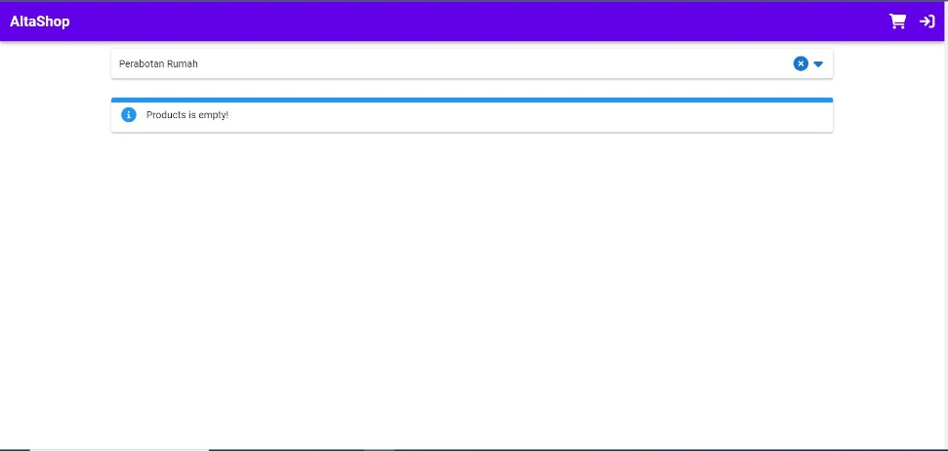

# **ALTA SHOP MOBILE BUG**

1. **Register User**

|  |  |
| --- | --- |
| Defect ID | MOB01 |
| Test ID | TCR_001 |
| Case | User register with invalid email credentials |
| Report Date | 10 Mei 2023 |
| Priority | High |
| Expected Result | Failed to register user account |
| Actual Result | No error message appears and successfully to login and direct to homepage Successfully to register user account |
| Report To | Android Developer |

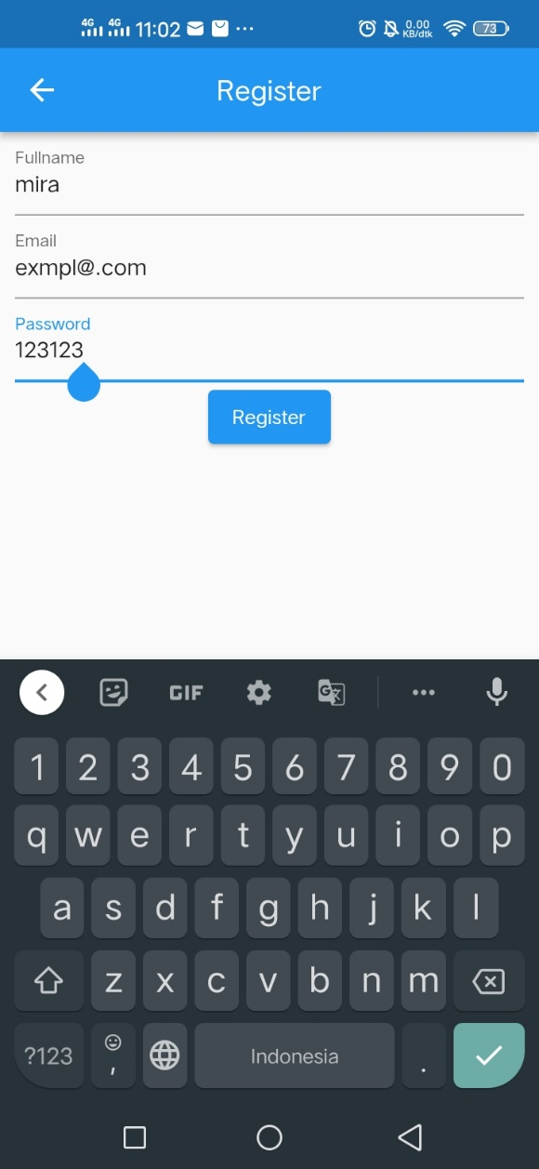

1. **Detail Product**

|  |  |
| --- | --- |
| Defect ID | MOB02 |
| Test ID | TCR_002 |
| Case | Click on product to view details |
| Report Date | 10 Mei 2023 |
| Priority | High |
| Expected Result | Displays the product details |
| Actual Result | Can't displays the product details |
| Report To | Android Developer |

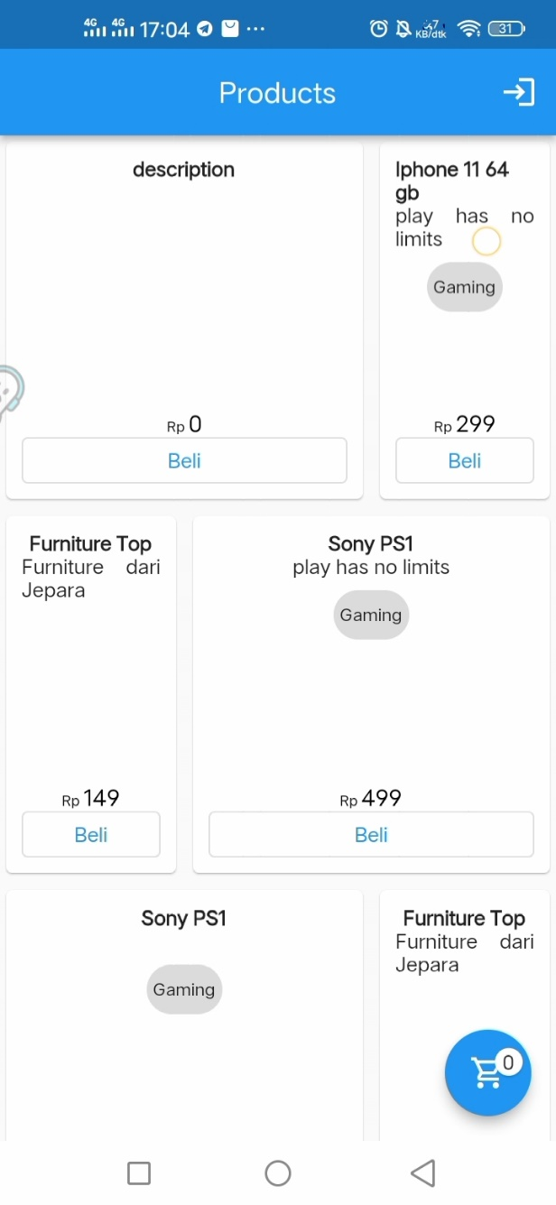

1. **Cart Menu**

|  |  |
| --- | --- |
| Defect ID | MOB03 |
| Test ID | TCR_003 |
| Case | Click on cart to view all products recently added to cart |
| Report Date | 10 Mei 2023 |
| Priority | High |
| Expected Result | View all product recently added to cart |
| Actual Result | Can't view all product recently added to cart |
| Report To | Android Developer |

